Final Project Proposal Assignment
Before beginning your final website project, you must submit a project proposal outlining your website idea and initial design plan. This proposal will help you organize your ideas, receive feedback, and ensure your project meets the course requirements before development begins.
Purpose
The purpose of this assignment is to help you:
- Plan the structure of your website
- Clearly define your website topic and audience
- Outline the pages and content you will create
- Begin thinking about layout, navigation, and responsive design
Proposal Requirements
Your proposal should be 1–2 pages and include the following sections:
1. Website Topic
Describe the topic of your website. Explain what the website will be about and why you chose this topic.
Include:
- The name of your website
- A short description of its purpose
- The target audience (who will use the site)
2. Planned Website Pages
List the minimum five pages you plan to include on your website.
3. Design and Layout Ideas
Briefly describe how you want your website to look and feel.
Consider:
- Color scheme
- Font styles
- Page layout
- Overall style (modern, minimal, professional, playful, etc.)
You should also mention how you plan to use Bootstrap and responsive design.

5. Rough Page Sketch (Wireframe)
Include a simple sketch or wireframe of your homepage layout.
This can be:
- Hand-drawn and uploaded as an image, or
- A simple digital sketch. You can use figma(free starter plan) or draw.io
Your sketch should show:
- Header
- Navigation menu
- Main content area
- Images or sections
- Footer
The sketch does not need to be perfect, it just helps visualize your layout. Example of what this looks like is provided below
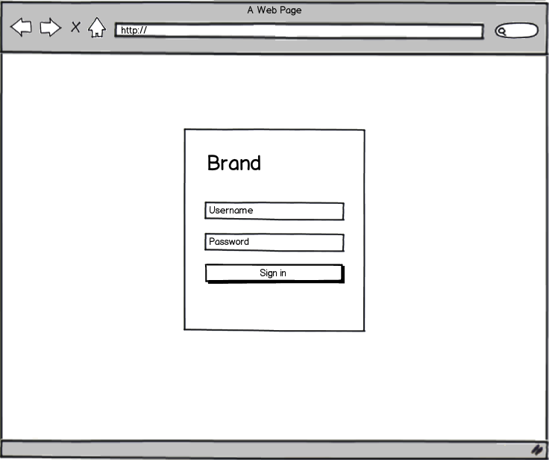
Submission Requirements
Submit the following:
- Project proposal document (1–2 pages)
- Homepage sketch or wireframe image
Upload your submission as PDF or Word document.

